„IVD-Praxishandbuch Dichtstoffe“ in English:

„The Sealants Manual“ now available

– Practical guidelines for the use of construction sealants –

The “Praxishandbuch Dichtstoffe”, whose first edition was published in 1988, has long become the standard reference book in German-speaking countries when it comes to sealing joints in the construction industry. Now this practical handbook is also available in English, as “The Sealants Manual – Practical guidelines to the use of construction sealants”. Globalisation does not stop at the seam—the new manual is the standard also in international markets, especially in the Far East and Eastern Europe, and the key to opening up new markets in the quality segment.
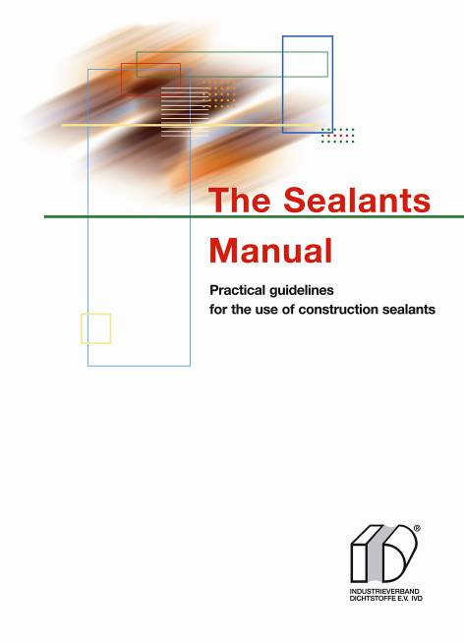
Seals the ”joint” between the national and international
market: the new “Sealants Manual”.

“Made in Germany” continues to be a label for excellence. This is true of products with the IVD quality stamp, and equally for German quality standards and norms. Because working in accordance with German industrial standards and offering products and technical services that conform to DIN, has proven to be a recipe for success, even outside Germany – and one that companies in the Far East and Eastern Europe are adopting with increasing enthusiasm.
This is where “The Sealants Manual” closes the gap between national and international markets. The up-to-date manual is essential for anyone carrying out sealing and caulking operations, for architects, civil engineers and investors in international markets. The book is available at a price of 49,60 Euros plus VAT, processing, postage and packaging costs, from INDUSTRIEVERBAND DICHTSTOFFE E.V. (IVD),
IVD-Geschäftsstelle, Marbacher Straße 114, D-40597 Düsseldorf,
Fax 49 211 90486-35, by e-mail to info@ivd-ev.de or directly on the Internet at www.ivd-ev.de. Here you will also find an overview of other informational publications by the IVD that are already available. HS

INDUSTRIEVERBAND DICHTSTOFFE E.V. IVD
Postfach 180341, D-40570 Düsseldorf

Editors: Pictures:
HS Public Relations GmbH HS / IVD
Louis Schnabl
Marbacher Straße 114
D-40579 Düsseldorf
Fon +49 211 90486-0
Fax +49 211 90486-11
eMail info@hs-pr.de

